HEAD FIXATION RIG ASSEMBLY

Table 1: Hardware

|  |  |  |  |  |
| --- | --- | --- | --- | --- |
| **Item** | **Amount** | **Spec.** | **Ordering** | **Lab storage location** |
| ThinkPad computer | 1 |  |  | NA |
| Monitor | 1 |  |  | NA |
| HARP behaviour board | 1 |  |  |  |
| HARP SoundCard | 1 |  |  |  |
| Breakout boards | 3 |  |  |  |
| Capacitance PCB | 1 |  |  | Pimoroni box in soldering room |
| Speaker | 2 |  | ? | ? |
| Raspberry Pi | 1 |  |  | Pimoroni box in soldering room |
| Pi camera | 1 |  |  |  |
| Ethernet cables | 3? |  |  | Box in Akrami lab shelves, floor 3 lab space |
| Solenoid valves | 2 |  |  | Under desk drawers, 311 |
| Tubing | 3 |  |  | Under desk drawers, 311 |
| Syringe | 1 |  |  | Under desk drawers, 311 |
| Tube-splitter? | 1 |  |  | Under desk drawers, 311 |
| Lick spouts | 3 |  |  | Soldering room, box in organizer shelf labelled ’head-fix’ |
| LED | 3 |  |  | Soldering room, box in organizer shelf |
| M3 thumbscrews | 2 |  |  | Soldering room, box in organizer shelf shelf labelled ’head-fix’ |
| M3 metal threading | 2 | Open bottom | NA | Fablabs |
| M3 bolts & nuts |  |  |  | Soldering room, box in organizer shelf |
| M4 bolts & nuts |  |  |  | Soldering room, box in organizer shelf |
| M6 bolts & nuts |  |  |  | Soldering room, box in organizer shelf |
| Thorlabs items: see IBL instruction |  |  |  |  |
| Rubber sheet | 2 |  |  | Fablabs |

Table 2: 3D prints

|  |  |  |  |
| --- | --- | --- | --- |
| Item | Amount | Material | File |
| Mouse tube stand | 1 |  |  |
| Tube roof | 1 |  |  |
| Tube poop tray | 1 |  |  |
| Headbar holder | 1 |  |  |
| Headbar stoppers | 2 |  |  |
| Paw support | 1 |  |  |
| Lick spout holder | 1 |  |  |
| RPI camera holder front | 1 |  |  |
| RPI camera holder middle | 1 |  |  |
| RPI camera holder back | 1 |  |  |
| RPI shelf |  |  |  |
| Electronics platform |  |  |  |

1. Base frame: see IBL
2. Head fix Icon

   Description automatically generated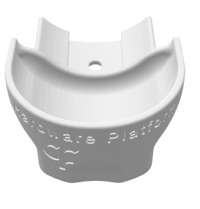Icon

   Description automatically generated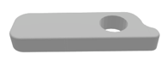
3. Reward delivery system Icon

   Description automatically generatedA picture containing electronics, jack

   Description automatically generated